

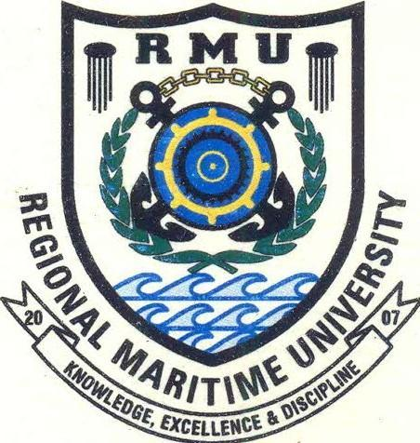

Regional Maritime University

Post Office Box GP 1115, Accra, Ghana Tel: (+233 302) 712775 /712343 /718225. Fax: (+233 302) 712047. Registrar Tel/Fax: (+233 302) 714070

MY REF: ${Letter_Reference} ${Letter_Date}

YOUR REF:

Dickson Korletey Tachie

Ada-foah - Ada-foah, Greater Region

P. O. Box 36, Ada-foah

Ghana

**OFFER OF ADMISSION TO 4-YEAR B.SC. NAUTICAL SCIENCE [2023-2024]**

With reference to your application for admission to the undergraduate 4-year programme of this University, I am pleased to inform you that you have been offered admission to the Degree (8 semesters), full time, regular B.Sc Nautical Science Degree Programme for the 2023-2024 academic session commencing on Tuesday January 23, 2024.

Please take note of the following conditions relating to your admission:

1. Payment arrangements of the semester’s tuition fee are as follows:
2. Make initial non-refundable fees of **Two Hundred US Dollars [US$200]** or its cedi equivalent to guarantee your admission and submit pay-in-slip to the Finance Directorate of the University to obtain official receipt. This payment shall form part of your fees.
3. You are required to Pay fifty percent (50%) of the first semester fees before reopening on Tuesday January 23, 2024. However, you can negotiate flexible payment terms by calling telephone number **0244456844/0243654920** or email [registrar@rmu.edu.gh](mailto:registrar@rmu.edu.gh).
4. Payment of the remaining fifty percent (50%) should be effected two weeks prior to the commencement of the 1st semester examination.
5. Thereafter, report at the Registry on or before Tuesday January 23, 2024 with the original and photocopy of the following:

* Letter of Admission
* Receipt of payment obtained from the University and
* Duly completed Acceptance Form

as a confirmation of your acceptance of the offer of admission.

1. From **Tuesday January 23, 2024 to Monday February 26, 2024** between the hours of **0800 hours and 1200 hours** you are required to present the  **original and photocopy of each**  of the following to the Registry for screening and mandatory medical examination.

* Letter of admission
* Birth Certificate
* Original copies of all relevant documents (result slips; certificates etc.) cited in the admission application form.
* Chest X-ray (original only) and corresponding Radiologist report taken not more than 2 weeks on receipt of this offer of admission.

1. The University will arrange for all students to acquire the National Health Insurance Identity Card.
2. Limited accommodation is available and is reserved for the 1st and 2nd year Marine Engineering and Nautical Science

students who are required to undergo mandatory cadetship training. Fresh foreign students will be considered on first come, first served basis. Other students and sponsors may apply to the Students Coordinator for the hostel accommodation and each application shall be considered on its own merit. Otherwise, students are expected to make private arrangements for accommodation. Those granted accommodation shall be required to vacate their rooms during Christmas and inter-semester breaks or whenever the University is on recess.

1. Non-Ghanaian students should note that residence permits are required for the confirmation of their admission and as such, such affected students are strongly advised on arrival to contact the Public Relations Unit immediately for assistance.
2. You are also required to attend a mandatory orientation programme for all freshers on Tuesday February 27, 2024 partial fulfillment of your registration/studentship of the University.
3. **Please note that the offer will be withdrawn and your place given to another applicant on the waiting list by Friday March 1, 2024 if you do not pay and submit the Acceptance Form with evidence of payment to the Registry.**
4. Please also note that, it is the policy of the Government of Ghana that all international students living in Ghana for a period of ninety [90] days or more would be required to obtain a Non-Citizen GhanaCard. The registration fee for the card is **One Hundred and Twenty US dollars [US$120].**

You are thus required to make adequate financial provision for the purpose of obtaining the cards.

1. Any further clarification regarding this offer of admission should be directed to the undersigned.

Congratulations and Best Wishes

**Dr. Baboucarr Njie**

**University Registrar**

**Note:** *Your admission is provisional and could be revoked unless your credentials have been successfully screened and also declared medically fit.*

*ENCS. i. Acceptance Form (To be filled and submitted with originals and photocopy of University receipts)*

*ii. Fee Schedule for 2023-2024*